**Research tasks**

**The hall of entrepreneurs, patrons and benefactors of the 19th - early 20th century**

1. **To the left of the entrance study the gallery of portraits of famous entrepreneurs and find an advertising image. Answer the questions:**
2. What is the name of the merchant depicted in the portrait?
3. What were his business and charitable activities?
4. What material is the exhibit made of?
5. Why can the exhibit be called an advertising image?

________________________________________________________________________________________________________________________________________________________________________________________________________________________________________________________________________________________________________________________________________________________________________________________________________

1. **Find the exhibit devoted to the business of the Kashtanovs, study it and answer the questions:**

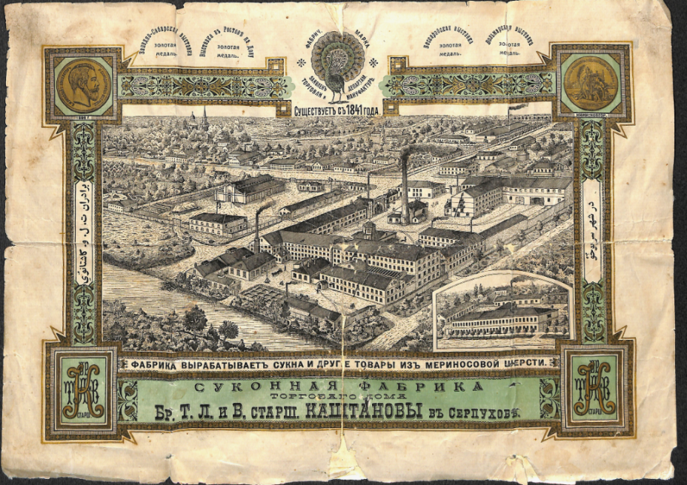

1. When was the Kashtanovs’ factory founded?
2. Where was it situated? What symbol of the place can be found on the trade mark?
3. How many Kashtanov brothers were there in the business?
4. The family business followed the order of Peter I: *“Garrison regiments of all provinces should have their uniforms, caftans, doublets, and trousers made from Moscow cloth, but not from imported overseas cloth……”* Explain how the entrepreneurs made a contribution to the process of import substitution.

_______________________________________________________________________________________________________________________________________________________________________________________________________________________________________________________________________________________________________________________________________________________________________________________________________________________________________________________________________________________________________________________________________________________________________________________________________________________________

1. **Match the letters to the numbers (there are two extra pictures):**
2. 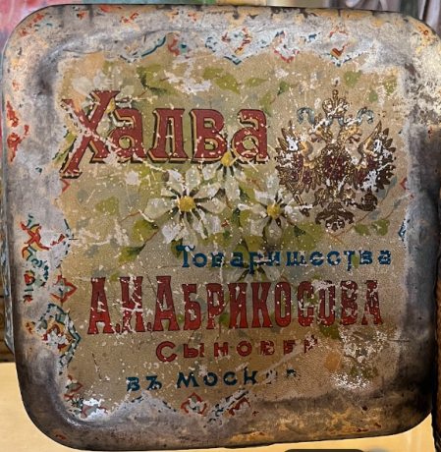 2. 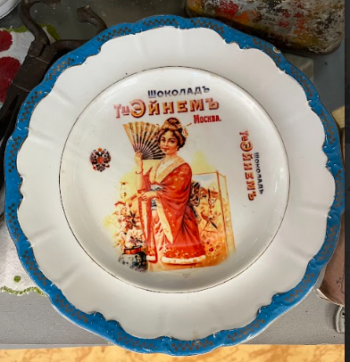
3. 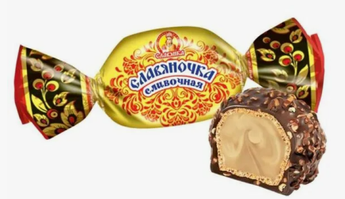 b) 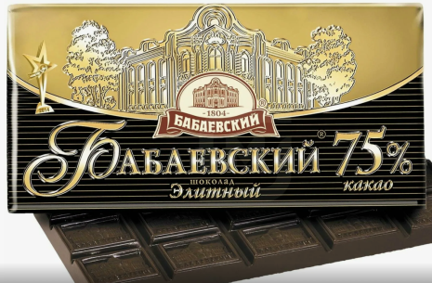

c) 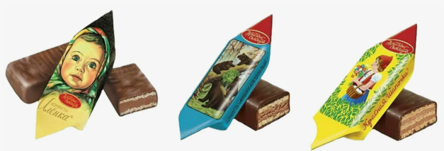 d) 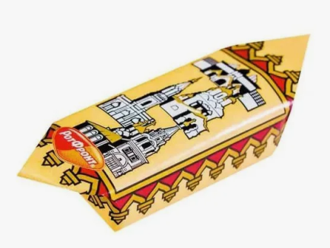

_________________________________________________________

**4. Study the showcase devoted to the Alekseev family. Find the famous representative of the dynasty (see the photo) and write his pseudonym:**

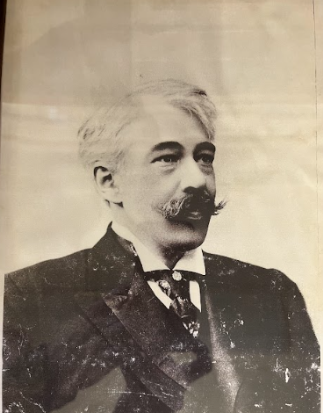

Among the Alekseevs was the famous theatre reformer, who began his career at his father's factory, where they made gold and silver thread. He took the pseudonym ………………………….. in 1885 at the age of 22 in order not to "disgrace his family" with too strong a passion for the theatre.

________________________________________________________

**The hall of joint-stock business, financial and stock markets of Russia of the 19th - early 20th century**

**5. The von Meck dynasty was engaged in the construction and development of Russian railways (see photos and comments in the hall). Why was it important for the country? What were the areas of charitable activity of the von Meck family?**

**___________________________________________________________________________________________________________________________________________________________________________________________________________________________________________________________________________________________________________________________________________________________________________**

**6. Study «Moscow city plan with suburbs», find the railway surrounding the city. What modern transport structure corresponds to this railway?** (choose the picture) **What is its modern name?** (choose the option)

1. 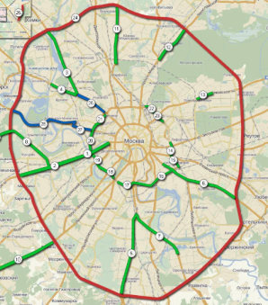 2. 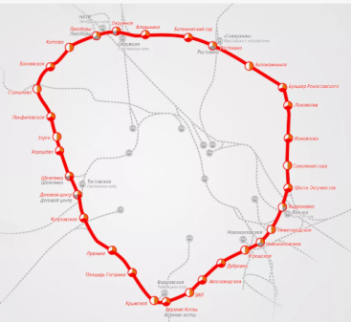 3. 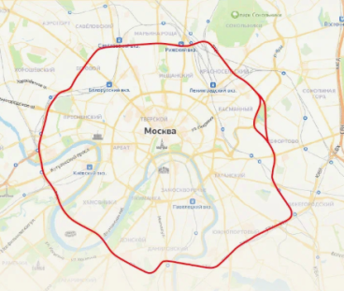

A) Third Ring Road (ТТК)

B) Moscow Ring Road (МКАД)

C) Moscow Central Circle (МЦК)

**What English unit of measurement is used in the scale?**

**________________________________________________________________________________________________________________________________________________________________________________________________________________________________________________**

**The hall of upbringing and education of children in the 19th - early 20th century**

**7. Study the candy wrappers on the wall. What educational value do they have? How can they be used at the lessons? What school subjects do they represent?**

**e.g. 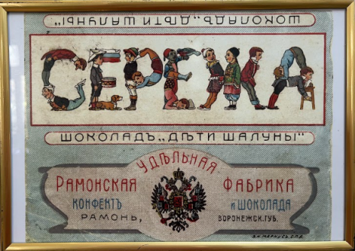 , 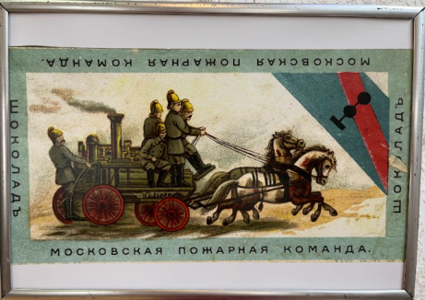 etc.**

**__________________________________________________________________________________________________________________________________________________________________________________________________________________________________________________________________________________________________________________________________________________________________________________________________________________________________________________________________________**

**8. Read the rules for the students in the showcase and say if the statements are TRUE (T) or FALSE (F).**

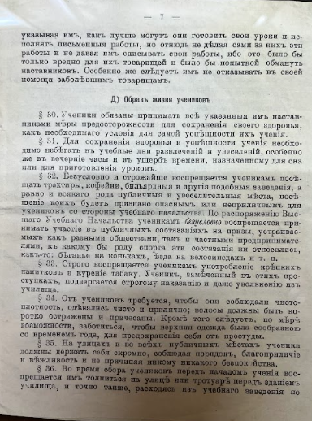

1. Students could not copy assignments from their friends or let them copy their work. __________
2. They were not allowed to help their ill groupmates.__________
3. On school days, students could only have fun in the evenings. ________
4. Students were forbidden to visit coffee shops, taverns, billiard rooms. ____
5. Students could take part in various competitions in order to receive prizes. _________
6. Students could be expelled from the school for smoking or drinking alcohol. _________
7. Students were not allowed to have long hair. ______
8. Students were supposed to behave modestly and politely only at school.________
9. Before classes, students could gather on the sidewalk in front of the school and chat. _______